Program Implementation of Generative Adversarial Networks
Yong-Jin Lee
CSC580
CSU Global
Joseph Issa, Instructor
9/10/2023

Network Performance
The main parameters that the GAN were having a batch size of 32 and an epoch size of 15,000. A momentum of 0.8 was used for batch normalization so that the network can converge faster in order to provide better image quality. The alpha value for LeakyReLU activation was set to 0.2 to better improve the overall performance of the GANs by managing dead neurons. A value of 0.25 was set for dropout to help prevent overfitting and making the model generalize better to unseen data. At the first epoch, the images are blurred to the extent that no discernable detail can be observed. The images produced at the 100th epoch still have significant noise; however, it can be clearly seen that the main structure of a boat is presented on the bottom of the images while the slight silhouette of a sail can also be ascertained.

Images of First Epoch
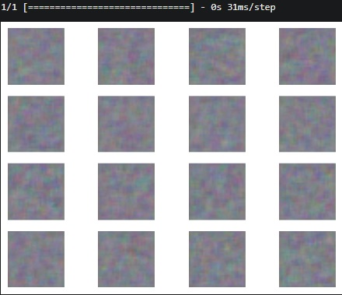
Images of 100th Epoch
